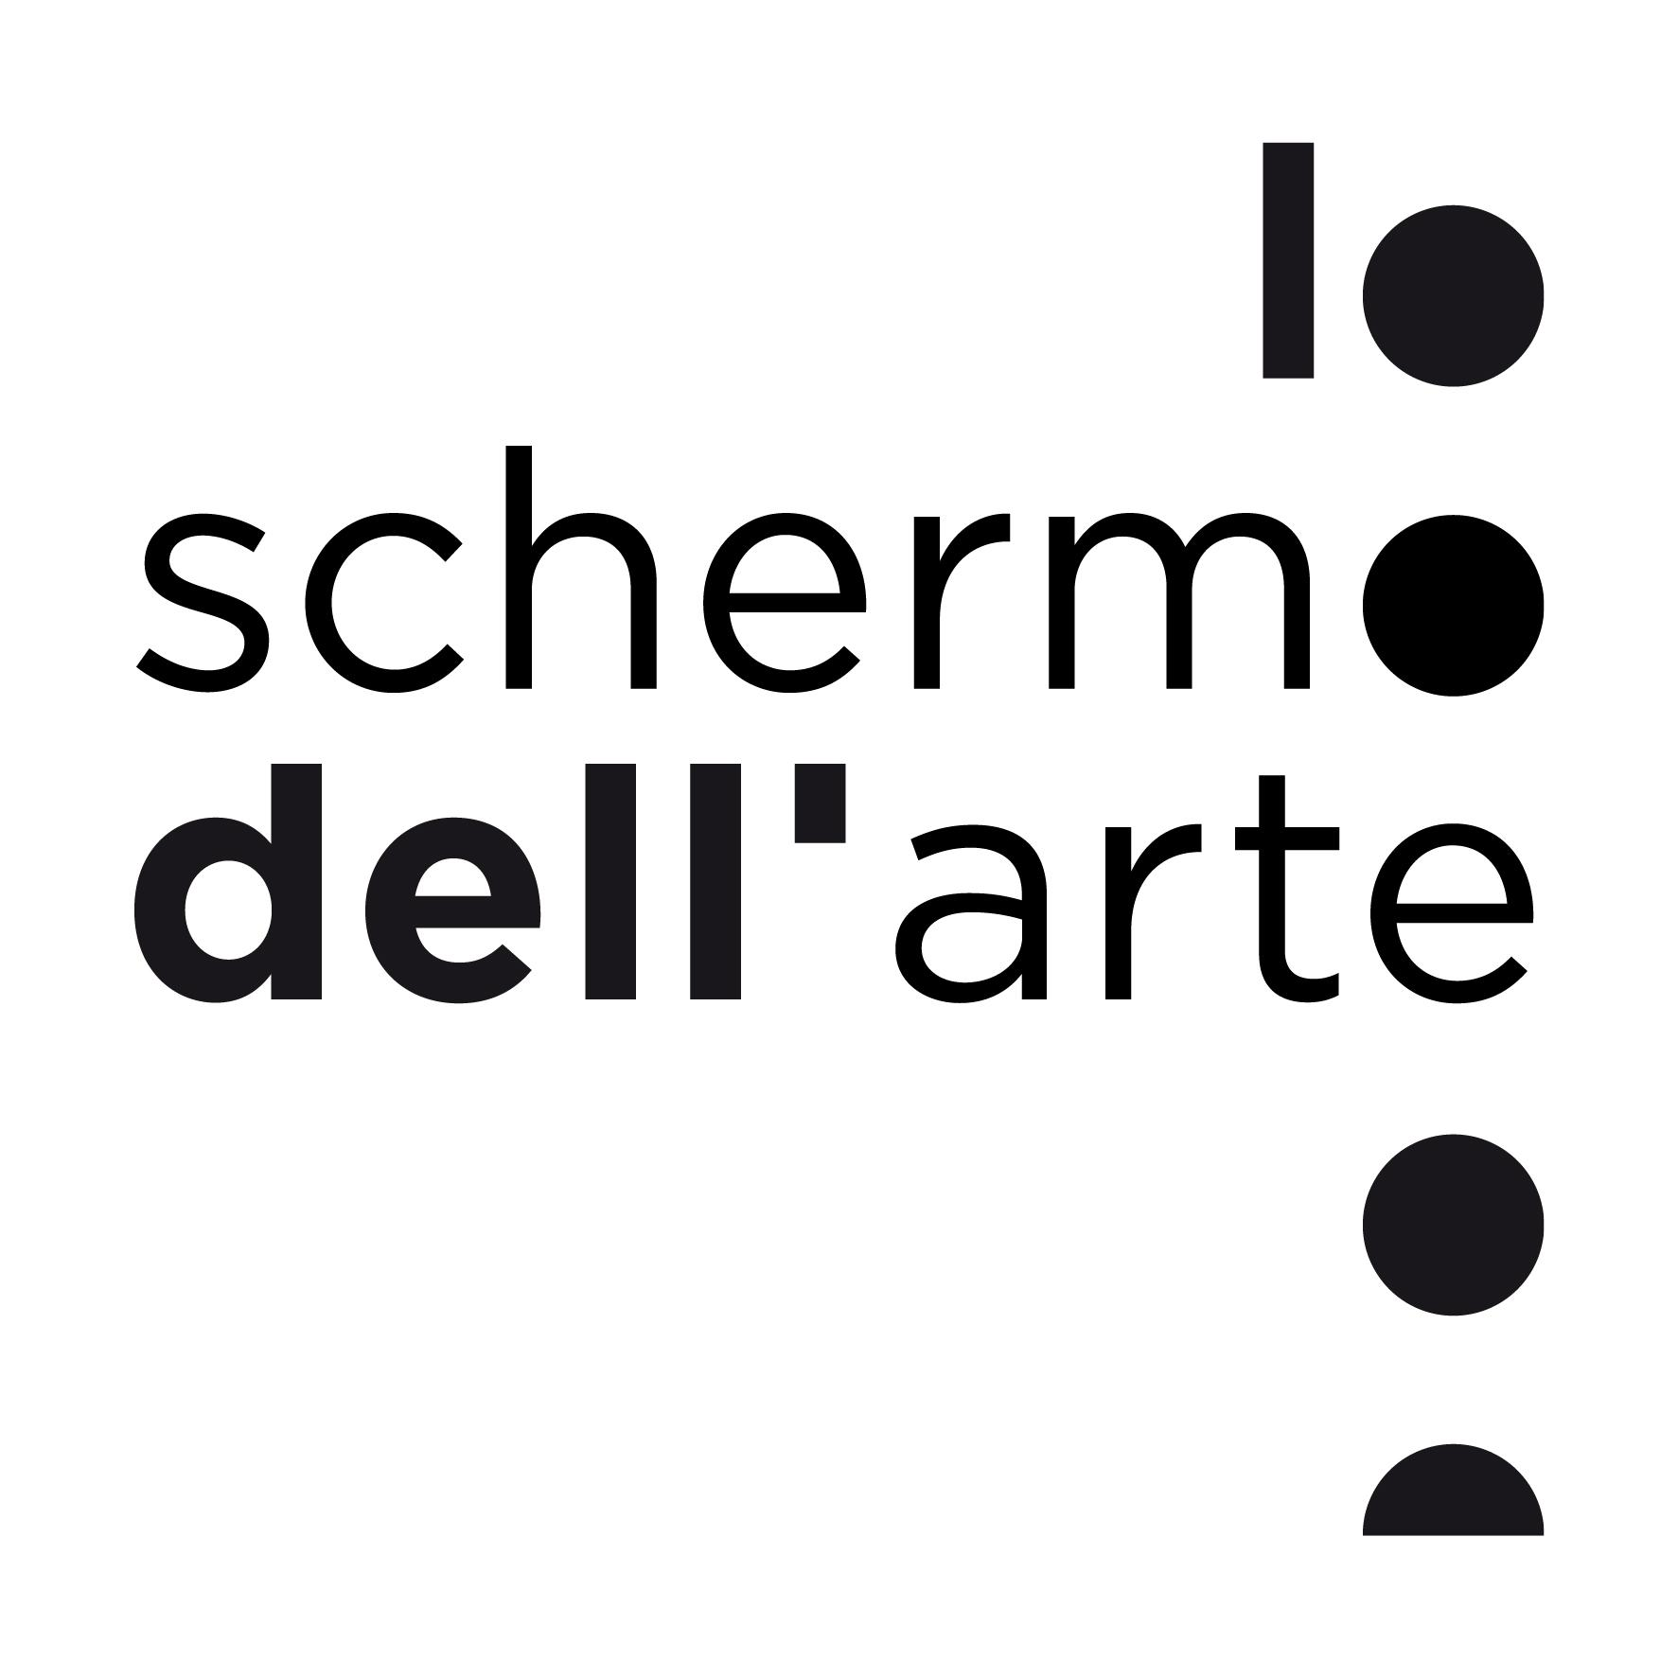

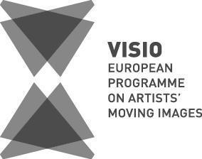

**VISIO - European Programme on Artists’ Moving Images**

**14th Edition**

**Florence, November 12- 16 2025**

**APPLICATION FORM**

***1. Deadline:***

**Friday, May 23rd, 2025, 11:00 p.m. (CET)** Late entries will not be considered.

Complete Applications must be sent to Livia Polacco at **visio@schermodellarte.org**

The 8 selected candidates will be notified by **Tuesday, September 30th, 2025,** at the latest.

***2. Requirements:***

Candidates must be visual artists who:

* work with moving images as part of their artistic practice
* are under 35 years old (born in 1990 or after)
* are citizens or residents of one of the 46 member countries of the European Council + Kosovo (for the complete list, see <https://www.coe.int/en/web/portal/46-members-states>)
* have had a relevant number of solo and/or group exhibitions in the last 3 years
* have an excellent knowledge of the English language

In case of an artist duo or collective, all members must meet the listed requirements and the collective must have a documented collaborative practice of at least 3 years.

***3. Required documents***

In addition to the Application Form, artists will need to submit:

▪ Production Budget (Annex A)

▪ Complete Curriculum Vitae (PDF)

▪ Portfolio with web links to previous video works (PDF)

▪ One portrait photograph with a resolution of at least 300 dpi (format: JPG or TIFF)

Optional Attachments:

a) Letters from institutional partners (museums, festivals, etc.), producers and/or financiers involved

b) Mood board, images and other visual aids

c) Links to video excerpts connected to the submitted work

The production budget (Annex A) consists of a detailed cost plan for the realization of the work. In the event that the production budget exceeds the amount of the VISIO Production Fund (10,000 euros), the economic contributions of other partners or co-producers must be indicated and documented.

If a production company is attached to the project, the Application Form must be signed also by a representative of the company.

Before submitting the application, please be sure that all the links included in the portfolio and in the documents attached are active. If needed, please provide passwords.

**4. Personal details**

Name/ Surname:

Address:

Phone:

E-mail:

Nationality:

Country of residence:

Birth date:

Website/ Blog:

Where did you hear about *VISIO - European Programme on Artists’ Moving Images*?

**5. Professional details**

Short biography in a narrative form (no more than 300 words):

Web links to at least 3 relevant previous works (full length):

**6. Project Description**

Title and detailed description of the concept of the work, expected format and estimated duration (maximum 500 words):

What is the stage of the production? Is there any other partner/ producer/ funder/ institution involved in the project? (Maximum 400 words):

*Please note that in the case of co-productions with other institutions/funders, the economic contributions of the other partners and/or co-producers must be indicated and documented with additional annexes to the application such as letters of intent on the partner’s letterhead.*

Why would you like to join VISIO - European Programme on Artists’ Moving Images and why do you think that this would be the ideal context to develop and produce this project? (Maximum 400 words):

If you are selected as one of the three artists awarded with the VISIO Production Fund (€10,000), how could the additional €5,000 made available by Human Company help to further develop and support this project? (Maximum 200 words):

*The €5,000, made available by Human Company, are intended as an additional support to raise the budget provided by the VISIO Production Fund for one of the three awarded artists.*

*Please discuss here the extra costs that could be covered thanks to the additional support of €5,000. These costs can include for example an increase of the artist’s fee, collaborator’s fees, rentals, research trips, etc. Please clarify how these extra funds will benefit the development of the project.*

**7. Disbursement of funds and eligible expenses**

If selected by the curator as one of the 3 funded projects, you will be awarded a production budget of 10’000 euros.

The disbursement of the VISIO Production Fund will be the subject of a subsequent production contract between the parties (Lo schermo dell'arte and the winner).

At the end of the production phase regular supporting tax documents must be submitted in return for the 10’000 euros received as the awarded sum (including the artist's fee).

80% of the contribution will be disbursed immediately after the contract has been signed, with the remaining 20% once the work is delivered and the accounting phase with the submission of supporting documents has been completed.

The additional €5,000, made available by Human Company for one of the awarded artists, will be disbursed immediately after the additional contract has been signed.

The co-production contribution of 5’000 euros of the FRAC Bretagne is part of the 2026 acquisition budget of the institution and, therefore, must go through the regulatory acquisition process via the approval of the acquisition committee (March 2026) and the final validation of the board of directors (May 2026). The contribution may be released at the end of this regulatory process.

All expenses directly related to the production of the project will be eligible, such as: artist's fees, fees for collaborators and technical staff, travel, board and lodging transfers, rental of spaces or location for filming, rental or purchase of technical equipment, post-production, translations and subtitles, shipping costs, costs related to the final support, insurance.

The work must be completed and delivered with English subtitles by October 1st, 2026.

**Terms and Conditions:**

If selected for the VISIO Programme I declare that I will attend the Programme arriving in Florence on Tuesday, November 11th and leaving on Monday, November 17th, 2025.

I declare that I own the rights of use for the submitted materials and that this does not collide with the rights of other third parties or collecting societies.

I agree that if selected as one of the 3 awarded projects, one of the editions of the work will be donated to the collection of one of VISIO’s institutional partners: Centro per l'Arte Contemporanea Luigi Pecci (Prato), Fondazione In Between Art Film (Rome), FRAC Bretagne (Rennes).

I agree that the work produced through the VISIO Production Fund will have its world premiere at Lo schermo dell’arte in November 2026. I may eventually discuss with the Curator the possibility of having the world premiere of the work at a major international film festival in 2026 (Cannes, Locarno, Toronto exclusively) before screening the film at Lo schermo dell’arte in November 2026.

I authorize Lo schermo dell’arte to use the materials (images, texts, video excerpts if not protected by password) for any promotional purposes in connection with VISIO - European Programme on Artists’ Moving Images and its activity, which may include: publications, website, press releases, social media. I authorize the treatment of my personal data in conformity with Personal Data Protection Code, issued with Italian Legislative Decree no. 196. dated 06/30/2003, and from 25 May 2019 by EU Regulation 679/2016 (as amended by Legislative Decree no. 101. dated 08/10/2019).

Lo schermo dell’arte informs that your personal data will be treated lawfully, correctly and transparently.

I hereby confirm and accept all the above terms and conditions.

Date

E-signature

In the case of co-productions with a recognized production company please complete also the part here below.

I hereby confirm and accept all the above terms and conditions.

Date:

Name of representative of the production company:

Role:

E-signature: